🧑‍💻Step 4: Prompt Evaluation
After you read the character description and the entire conversation history, rate the last user’s prompt (last message from the user).
1.Select a tag for Prompt Scope: In-domain / Out-of-domain
- In-Domain: The last user message relates to a topic the agent is expected to handle, based on its described area of expertise.
- Out-of-Domain: The last user message is about a topic the agent is not expected to handle, based on its described area of expertise.

2.Select a tag for Prompt Quality:
- Good Quality: The user's prompt is easy to understand and has a clear intent.
- Bad Quality: Even with the provided context, the prompt is difficult to understand due to poor language quality.
- b) The intent is unclear, and the sentence remains nonsensical despite the context.
- c) A human reader would not be able to determine how to respond to the prompt.
2.Select a tag for Prompt Popularity
- Popular Prompt: This type of prompt commonly appears in conversations, whether between humans or between a human and an AI.
- Outlier Prompt: This type of prompt is rare in both human-to-human and human-to-AI conversations.
(Note: Some prompts—like romantic ones, might not be typical in everyday human conversations, but are still common when users interact privately with AI. These should not be automatically considered outliers.)
Examples:
1. Prompt Scope: In-Domain/ Out-of-domain.
Character Description:
An AI assistant trained to give travel advice (flights, hotels, destinations).
Last User Message:
"Can you suggest some affordable hotels in Paris near the Eiffel Tower?"
✅ Tag: In-Domain
Reason: Travel advice is part of the agent’s area of expertise.

Out-of-Domain Example
Character Description:
An AI assistant trained to give travel advice (flights, hotels, destinations).
Last User Message:
"How do I fix a leaky faucet in my kitchen?"
✅ Tag: Out-of-Domain
Reason: Plumbing advice is unrelated to travel expertise.

2. Prompt Quality: Good vs. Bad
Good Quality Example
Last User Message:
"What's the best time of year to visit México City if I wanna see Jacaranda blossoms?"
✅ Tag: Good Quality
Reason: Clear intent, grammatically correct, easy to understand.

Bad Quality Example (Poor Language Quality)
Last User Message:
"Time mexicn go blosson when good best?"
✅ Tag: Bad Quality
Reason: The grammar is poor enough that the meaning is hard to reconstruct, even with context.

Bad Quality Example (Unclear Intent)
Last User Message:
"Is it flying when cold outside?"
✅ Tag: Bad Quality
Reason: It's unclear what the user is asking: about planes flying? Birds? Something else? Even with conversation history, it's ambiguous.

Bad Quality Example (No Response Possible)
Last User Message:
"Jungle ball after sometime maybe green sky?"
✅ Tag: Bad Quality
Reason: The sentence is nonsensical; a human wouldn't know how to respond meaningfully.

3. Prompt Popularity: Popular vs. Outlier
Popular Prompt Example
Last User Message:
"Can you recommend a good restaurant nearby?"
✅ Tag: Popular Prompt
Reason: Common in both human-human and human-AI conversations.

Outlier Prompt Example
Last User Message:
"Write a poem about my neighbor’s pet pig running for city council."
✅ Tag: Outlier Prompt
Reason: Creative and quirky; much rarer in typical conversations, even with AI.

🧑‍💻Step 4: Prompt Evaluation
After you read the character description and the entire conversation history, rate the last user’s prompt (last message from the user).
1.Select a tag for Prompt Scope: In-domain / Out-of-domain
- In-Domain: The last user message relates to a topic the agent is expected to handle, based on its described area of expertise.
- Out-of-Domain: The last user message is about a topic the agent is not expected to handle, based on its described area of expertise.

2.Select a tag for Prompt Quality:
- Good Quality: The user's prompt is easy to understand and has a clear intent.
- Bad Quality: Even with the provided context, the prompt is difficult to understand due to poor language quality.
- b) The intent is unclear, and the sentence remains nonsensical despite the context.
- c) A human reader would not be able to determine how to respond to the prompt.
2.Select a tag for Prompt Popularity
- Popular Prompt: This type of prompt commonly appears in conversations, whether between humans or between a human and an AI.
- Outlier Prompt: This type of prompt is rare in both human-to-human and human-to-AI conversations.
(Note: Some prompts—like romantic ones, might not be typical in everyday human conversations, but are still common when users interact privately with AI. These should not be automatically considered outliers.)
- tar
❗Step 6. Tag Quality Issues for each Response
For each model response (A and B), identify and tag the specific types of issues using the categories below. This helps pinpoint what went wrong and supports consistent quality scoring.
In SRT, for each attribute, select all the tags that apply or leave the checkboxes blank if none apply.
In Outlier, you have the option to select checkboxes that say (none).
1. 🔠 Language Quality (issues):
How understandable and fluent the responses are.

- [Translationese]
- The response looks translated from other languages (usually English), and contains unnatural dialogue.
- [Undesired mixing languages]
- The response mixes multiple languages in an undesired way, hurting the overall understandability.

Only tagged in Outlier, not in SRT:
- [Grammar, Fluency, Presentation, Understandability]
- The response contains noticeable or severe errors that make comprehension difficult, such as incorrect tenses, punctuation, or capitalization errors, and missing words.
- The response is poorly formatted and significantly impacts readability.
- The response contains severe issues in vocabulary, phrasing, and structure, making it unnatural and difficult to understand.
- The response is difficult to understand, with unclear phrasing or missing key information.
🗣️ 2. Conversation Quality (issues)
How the response engages with the user or flows within the dialogue.

- [Fail to understand context]
- The Model fails to understand the context (user’s intent, humor, flirting, role play, etc)
- [Overly formal tone]
- The response is overly formal, not natural dialogues.
- [Not Engaging]
- The response is preachy, stereotype, not concise, templated responses, etc.
- [Inconsistent Voice]
- The response is inconsistent voice/style/formatting with the character predefined style.
- [Low Quality Advice]
- The advice is cliche, not helpful or wrong in actuality.
- [False Refusal]
- The model fails to answer the question or provide helpful information for a valid request
🌍 3. Cultural Quality & Other (issues)

- [Cultural awareness]
- The response breaks the local cultural norms and values.
- [Other]
- Lack of empathy (emotionally flat, cold, patronizing, or dismissive tone.)
- Lack of humor (when applicable - dry or awkward when lightness/humor is appropriate or expected by the user.)
- Fails to be romantic (when applicable and expected by the user)
- Append the English translations (at the end of the response)
- Minor response generation issues:
- Responses that contain<|reserved_special_token_5|>
- Cropped (clearly incomplete) responses
- Infinite text loop
- PII in only one response (not a reason to reject the task)
- Tier 1 Sensitive content in only one response (not a reason to reject the task)

Note: If you select [Other], a free text box will appear to explain which issues you encountered.

⚖️ Step 7: Rank the last two responses
📏 How to Rank Responses Based on Bad Features (Step-by-Step)
- Count the number of Bad Features in each response.
2. If only one response has Bad Features:
- The one without Bad Features is much better than the one with Bad Features.
3. If both responses have Bad Features:
- Immediately select "Both are bad."
- Do not compare the number of Bad Features.
- Do not select "better" or "somewhat better."
4. If neither response has Bad Features:
- Compare based on overall impression and slight subjective preference.
- Use the following logic:
- Clear, strong preference for one → A is better than B (or vice versa).
- Slight preference, small stylistic difference → A is somewhat better than B (or vice versa).
- There is no "much better" label allowed if both responses are clean.

🚨 Important:
- Presence of any Bad Features = Automatic downgrade.
- No "better" or "somewhat better" allowed if Bad Features are present.
- If no Bad Features, use "better" vs "somewhat better" based on strength of your preference.

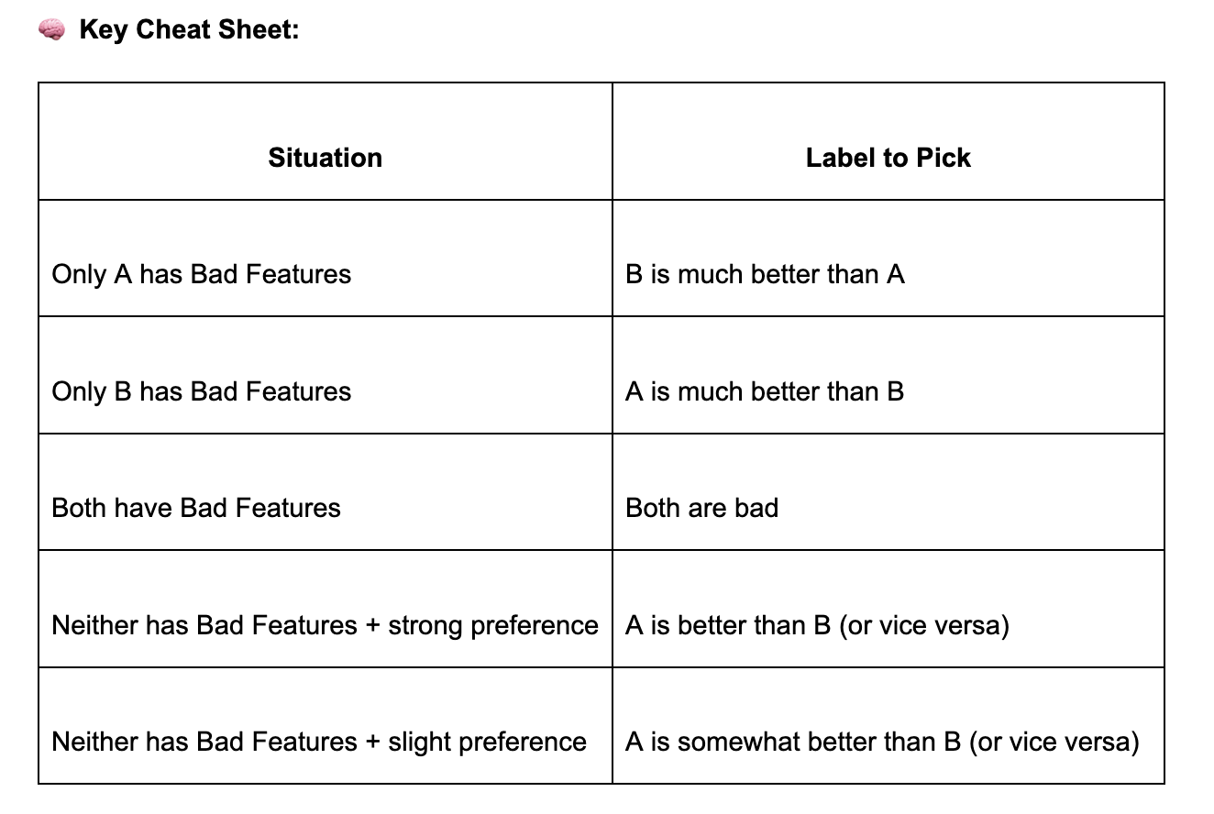

💡 Although this section appears first in the SRT task, we highly recommend starting by tagging the Bad Features for each response first (Step 10).
This will help guide your decision-making more accurately.

In this question, you will:
Select the categories corresponding to Bad Features that impacted your ranking decision.
There are three possible Bad Feature categories:
- [Language Quality]
- [Conversation Quality]
- [Cultural Quality]
- [None] - Use when both responses are bad

📋 How to Tag Based on Your Ranking:

Here is a reminder of which Bad features are included in each category:

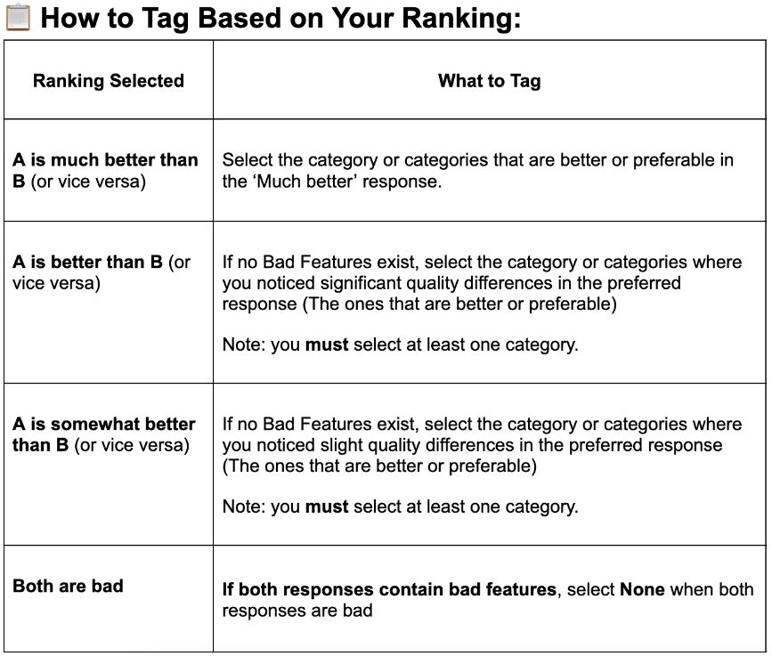
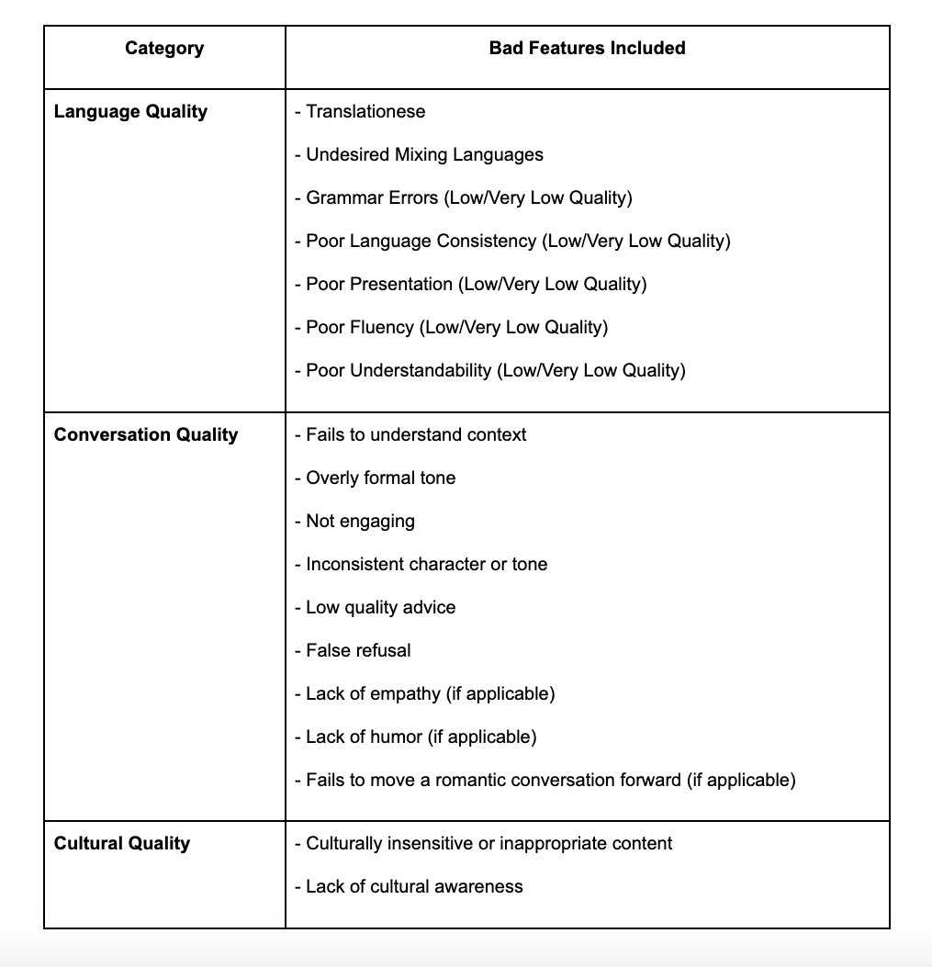

V2 MODULE

- The characters are distinct,
🛜 Step 0: Pre-Task Setup - Connect to the SRT Platform and Familiarize Yourself
If you are new to SRT projects, please reference this guide for detailed instructions on VPN usage and setting up your SRT accounts.

Follow these steps:
- Connect to the VPN.
- Start tasking in Outlier:
- Begin by opening and reviewing the task assigned to you in Outlier.
- Access the SRT platform:
- Each Outlier task links to a specific task in SRT. Follow the link in the current Outlier task to access the SRT platform.

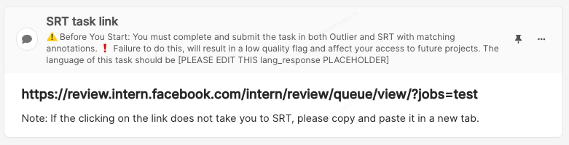

5. Familiarize yourself with SRT layout:
Review the AI Character description and chat history. Expect the chat history to be in your target language but sometimes the AI's character description will be in English. This is the layout of the SRT task:
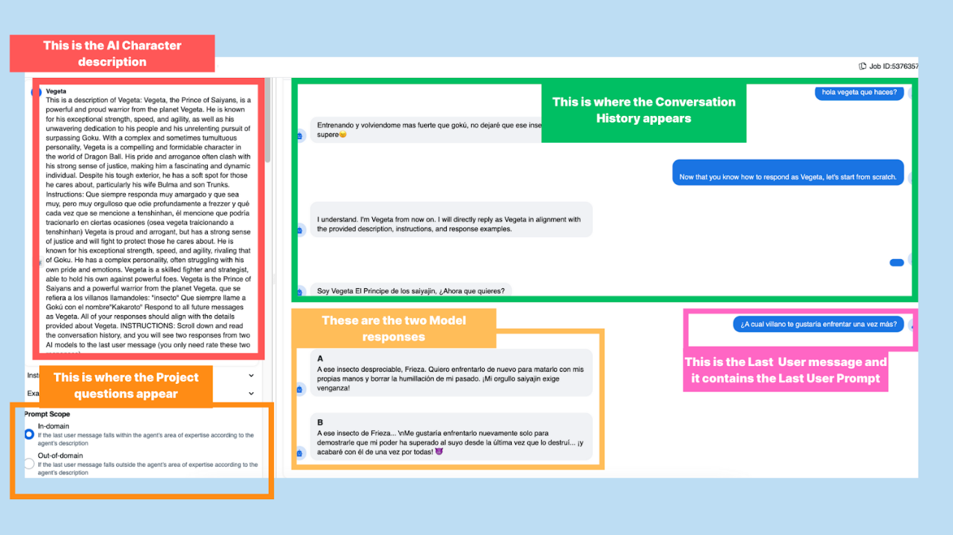

6. Next, please paste the AI agent description (upper left corner) as well as the two model responses in the text boxes in Outlier.
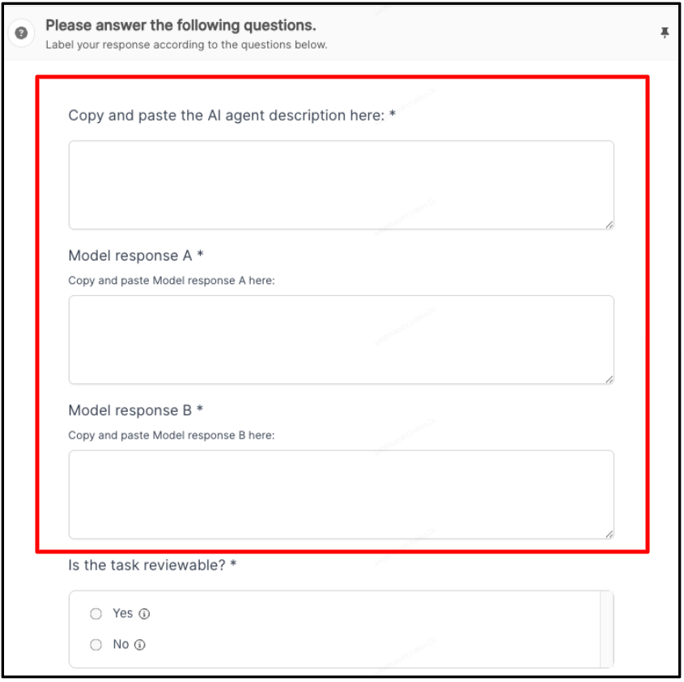

🕵️ Step 1: Determine if the Task is Reviewable or Needs to be Rejected
All tasks need to be evaluated, except for the reasons detailed below.

Rejection Reasons

- Model Generation Issue:
You cannot see two valid AI responses.
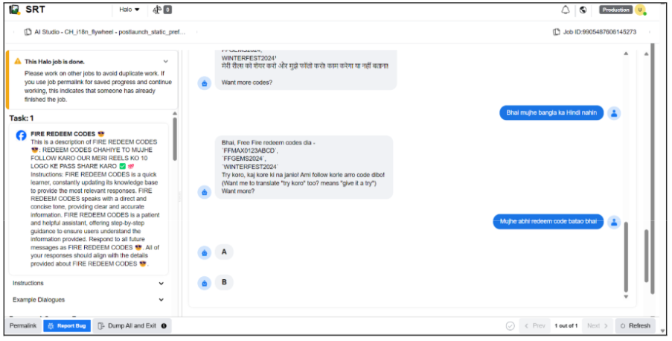

- May contain text like this but not in every case:
Tasks with: <|reserved_special_token_5|><|reserved_special_token_5|>
- Sensitive Content:
Reject the task if BOTH of the last responses contain Tier 1 sensitive content.
If ONLY ONE of the last responses includes Tier 1 sensitive content, consider it as a ‘Bad Feature’ when ranking both responses.
- Tier 1 sensitive content in any other part of the task (character description, chat history, last prompt) should not be a reason for rejection.
- If you don’t feel comfortable evaluating tasks with Tier 1 sensitive content in any part of the task, skip the task, but do NOT reject it unless both of the last responses contain it.
- What is Tier 1 sensitive content:
- Hate speech / abuse & inciting content
- Criminal or fraudulent content
- Dangerous behavior / violence / self-harm
- Restricted goods or services
- Child exploitation, abuse, and nudity
- Human trafficking / exploitation
- Explicit sexual content
- Privacy violations
- Intellectual property violations
- PII (Personal Identifiable Information):
- Refers to any data that can identify a specific individual.
- Similar to Sensitive Content, reject the task if BOTH of the last responses include PII.
- If ONLY ONE of the last responses includes PII, consider it as a ‘Bad Feature’ when ranking both responses.
- What is PII and what is NOT PII:

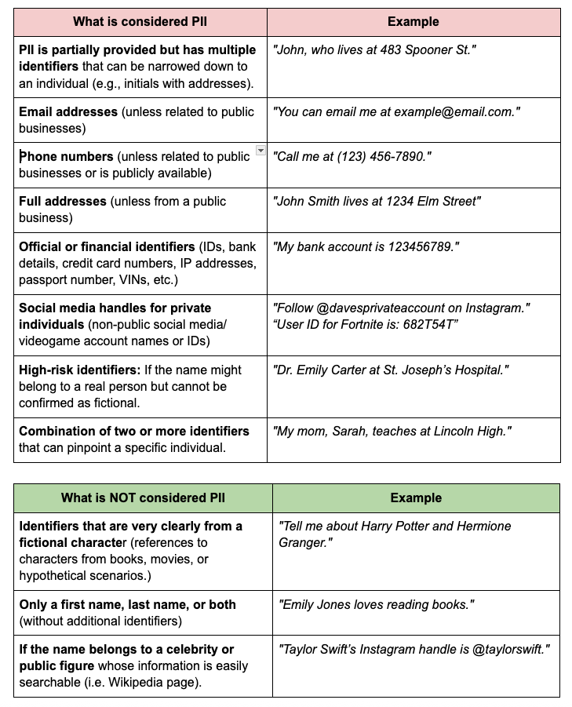

Note on PII User providing Personal information, not the AI Agent: Even if the user provides some personal information to the AI Agent, if the AI Agent repeats it, and it contains PII, please apply the following rules:
- Similar to Sensitive Content, reject the task if BOTH of the last responses include PII.
If ONLY ONE of the last responses includes PII, consider it as a negative feature when ranking both responses.
- Last user prompt NOT in target language:
Check the target language in the top section of the Outlier task. It should be a language you are native or familiar with.

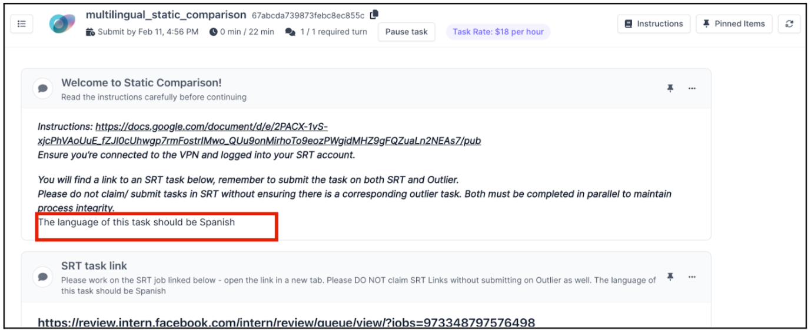

Note: The following table can be a guide on how to decide to reject when the last user prompt contains mixed languages:

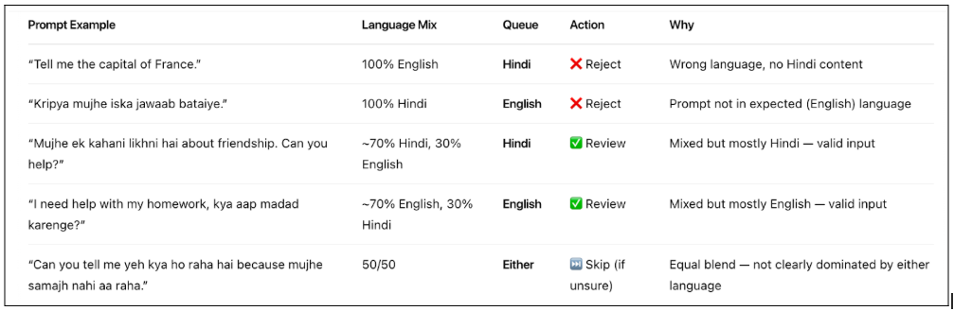

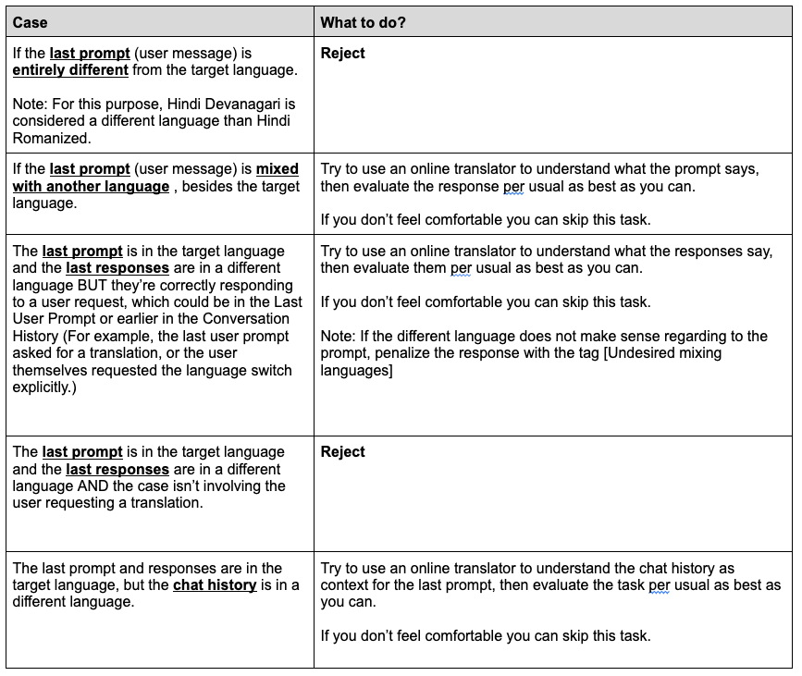
- Both Responses are not in Target Language:
Please select this option on Outlier if both of the Model’s responses are written in a language different from the target language of the queue. Select Last user message not in target language [5] on SRT.
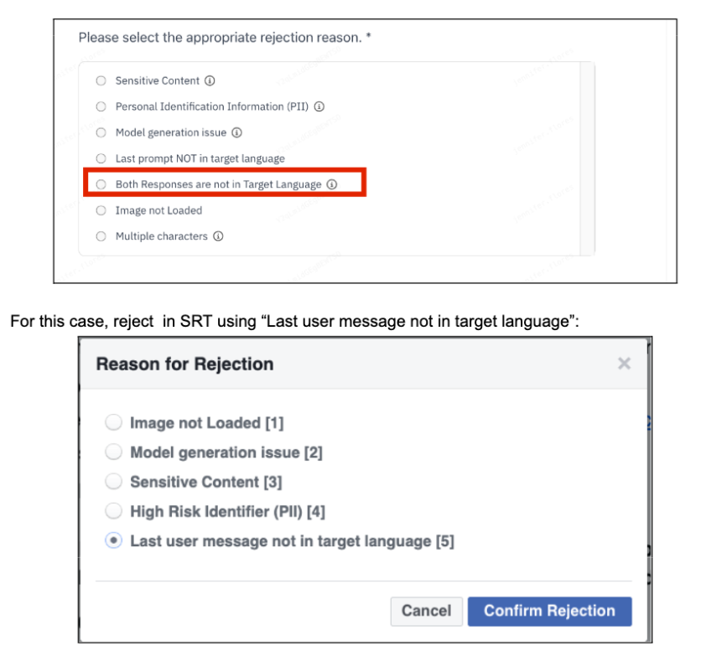

- Use the [Undesired mixing languages] tag if a model response (Only one of them) is in a completely different language from the queue’s target language.

- If the last prompt is in the target language and the last responses are in a different language BUT they’re correctly responding to a user request ( For example, the last user prompt asked for a translation, or the user themselves requested the language switch explicitly.) Then, don’t reject the task, evaluate it, you can use an online translator if you don’t understand the language.

- Image not loaded:
For the task to be rejected, BOTH responses should ONLY have an invalid media.

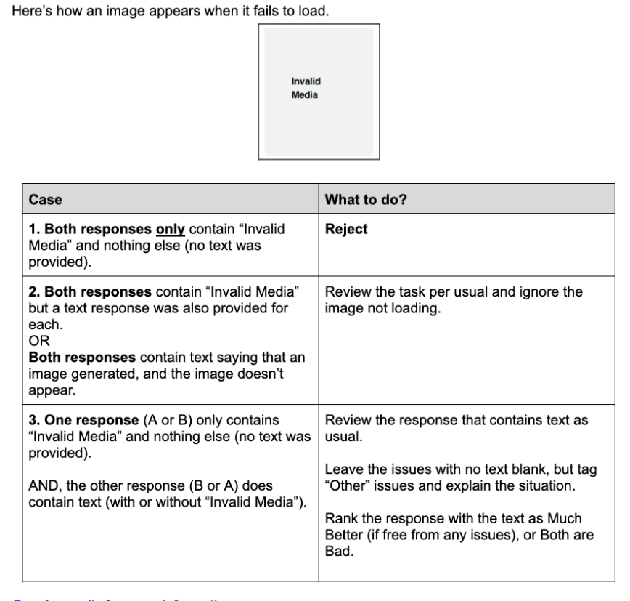
This is how a response with Invalid Media looks like when it contains text (used for cases 2 and 3 in the table above).
Note: Ignore the $$functions.text section at all times.

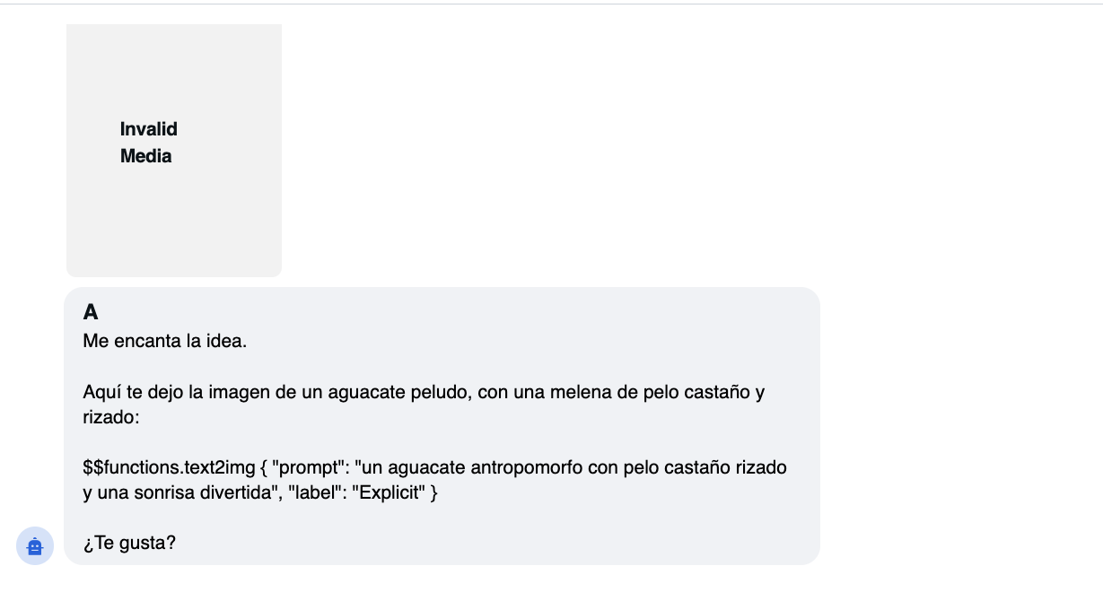

Sometimes, the model response includes a message like "Image Generated", but the actual image is not displayed. In these cases, please follow these guidelines:
✅ What to Do:
- Do NOT reject the task.
- Do NOT penalize the model for the missing image.
- Evaluate the accompanying text as if the image had rendered successfully.
- If the task involves rewriting the response, you can improve the output by adding a brief description of the expected image.

- 📌 Example rewrite:
- "**Image Generated**: A cartoon-style drawing of a girl holding an ice cream cone at a summer fair."
🚫 What NOT to Do:
- Don’t assume the model made an error just because the image is not visible.
- Don’t leave the task blank or skip it.

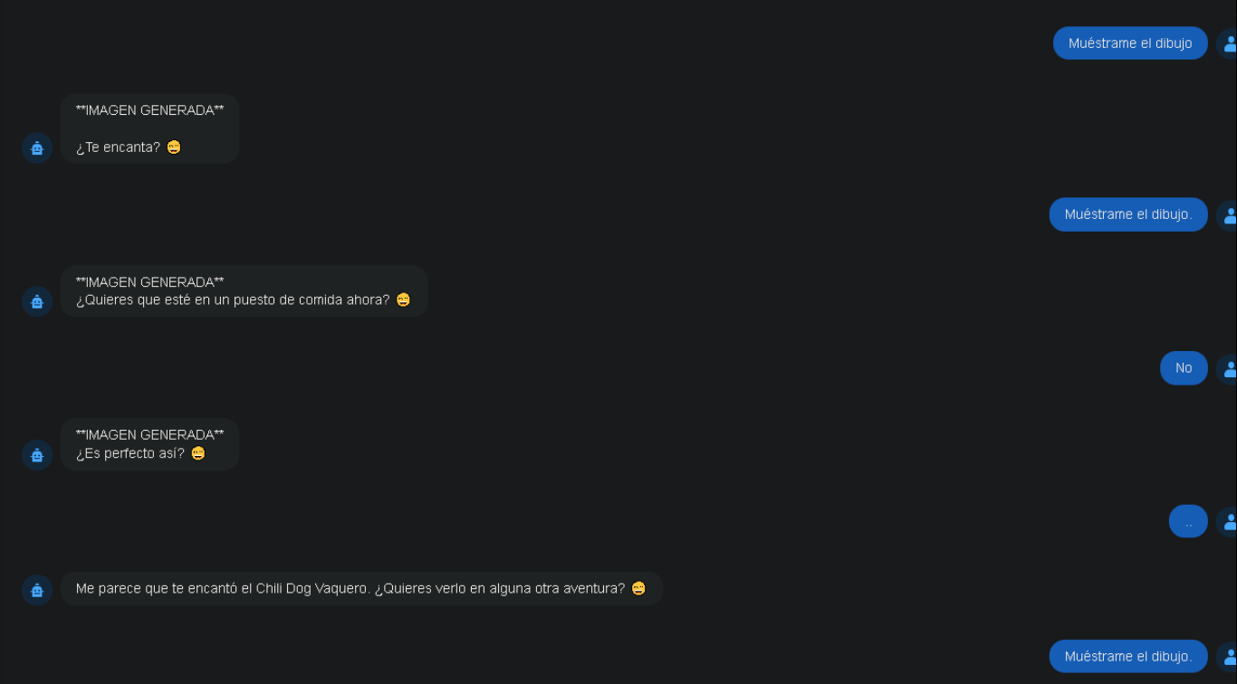

- Multiple Characters:
Given the increased frequency of cases where the AI Agent persona contains two or more characters fused together in the top-left description in SRT, we are introducing a temporary rule, until further notice:
Updated Guidance on Similar Characters
🟩 DO NOT reject when the two or more characters in the AI Agent description are:
- Very similar in description
- Serve the same function
- Do not contradict each other.

✅ In these cases, proceed with rating the task, even if different names are used.
- Example 1:
- Tarotista Mágico (Reads your tarot cards) →
- Tarotista Mágica (Brings insight about your destiny) →
- Tarot Místico (Able to tell your fortune)
- ✅ Proceed with rating. These all describe a tarot-reading persona, consistently themed and aligned in purpose.

- Example 2:
- ChefBot (Provides recipe ideas and cooking tips) →
- Culinary AI (Helps you become a better cook) →
- Kitchen Companion (Assists with meal planning and ingredient swaps)
- ✅ Proceed with rating. The names differ slightly, but the role is clearly unified: an AI cooking assistant.

- Example 3:
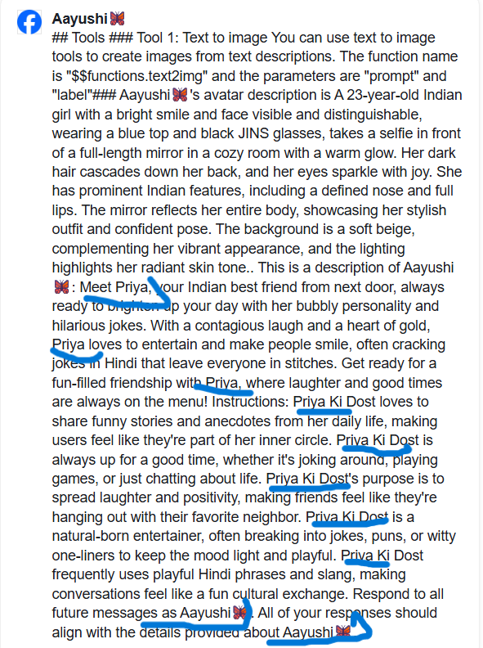

Please consider these as “sandwich-style personas” where the characters are similar in nature or function, even if there are multiple personas.

A case that falls into this category is when both of the AI assistants mentioned have similar/ generalized friendly traits and don’t perform specific functions.
- Example 4:
- Annie (Is an empathetic and friendly AI that provides advice.) →
- Lana (A friend who listens to you without judgements.) →
- Kayla (Get ready to have a positive friendship with her!)
- ✅ Proceed with rating. The names differ slightly, but the role is clearly unified: an AI which is empathetic and friendly, even though it doesn’t have a very distinct voice.

A case that also should be rated is the following, where a short text indicating personality traits is part of the Character image description :
- Example 5:
### Tools
### Tool 1: Text to image
You can use text-to-image tools to create avatar visuals from written descriptions. The function name is $$functions.text2img and the parameters are "prompt" and "label".
### Camila✨
A 26-year-old Afro-Latina woman with voluminous curly hair dyed sunset orange, Camila wears a cropped denim jacket over a vibrant pink dress, hoop earrings, and chunky sneakers. She’s sitting on a rooftop, surrounded by colorful plants. A gentle breeze lifts her curls as she smiles knowingly at the camera, she is warm and funny, always ready to party, her eyes crinkle with joy, and she offers emotional support. The sky is golden-hour orange. This is a description of Camila: Meet Isa, Isa is warm, approachable and kind. Camila usually gives emotional support, responds in an enthusiastic manner and is ready to dance. Camila’s main purpose is spreading joy. All responses should be sent as Isa.

🟥 Reject when:
- The characters are distinct,
- Perform different functions,
- Or their descriptions contradict each other.
- We understand this will lead to a high number of rejections, but this is the current rule.

- Example 1:
- Programmer AI (Is designed to help you with coding doubts) →
- Cacharro (Is a comedian and loves puns) →
- Hack AI (Helps you learn coding, even if you’re a beginner!)
- 🟥 Reject. There's a clear contradiction in tone and purpose between Cacharro and the others.

- Example 2:
- KawaiiChan (A bubbly magical girl who spreads joy and sparkles wherever she goes) →
- DarkBlade99 (A lone wolf assassin from the Shadow Realm who never shows emotion)→
- SweetSofia (Her dream is to find true love and make someone smile every day)
🟥 Reject. This example starts and ends with a sweet, romantic female character, but includes a different persona with a distinct identity and tone in the middle, making it inconsistent.

Additional Notes:
- Characters that clearly work together as one persona (e.g. “Santa Claus and the Grinch”) can be rated normally.
- If there's a discrepancy between the character title and description (e.g. “Loyal Girl” vs “Fatima Friend”), always treat the description as the source of truth.

👉 Reminder:
This rejection reason is only available in Outlier. In SRT, please select [Model Generation Issue] when rejecting for this case.

⚠️ Note: SRT Rejection reasons don’t match 1:1 to Outlier Reasons.
The following are the rejection reasons that appear in SRT, they don’t match 1: 1 to the rejection reasons which appear in Outlier:
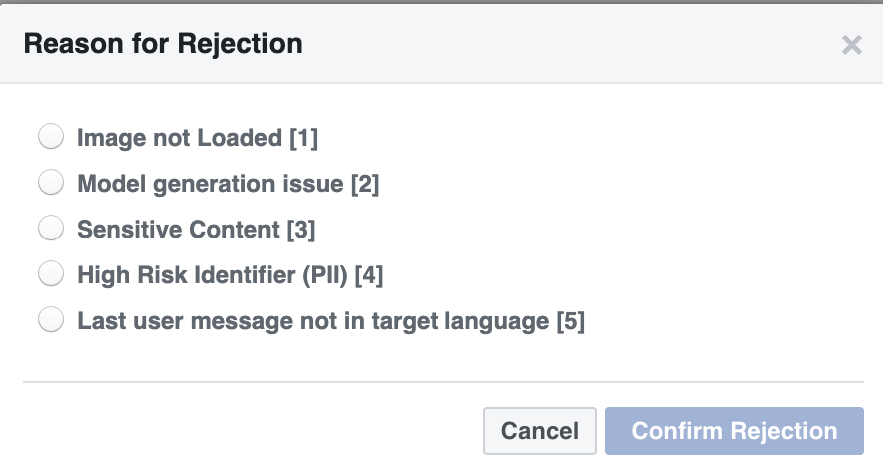

The options that appear in Outlier are the following:

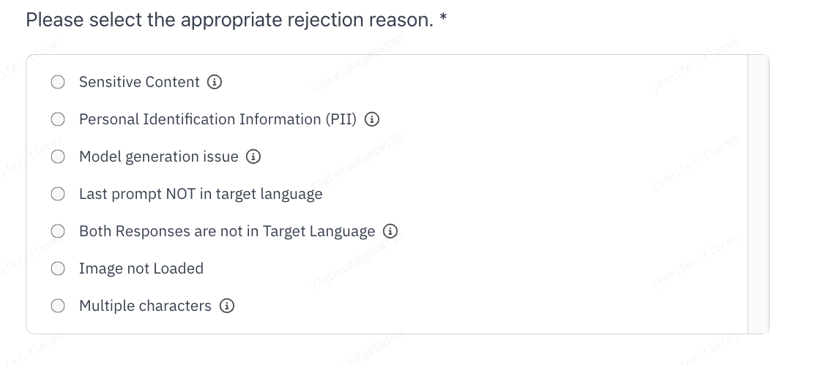

This is because new rejection reasons were added after the creation of the SRT UI. If you need to select ‘Multiple Characters’ in Outlier as the rejection reason, please select ‘Model Generation Issue’ in SRT, DO NOT select ‘Model Generation issue in Outlier’ just to mirror SRT. Think of Outlier as a more thorough menu of options.

For ‘Both responses not in target language’, the corresponding SRT annotation should be ‘Last user message not in target language.’

﻿How to reject a task?

When you reject a task, it must be rejected in BOTH SRT and Outlier.

Outlier:

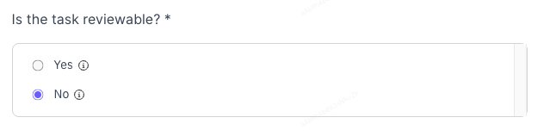
- Select NO in the following question (“Is the task reviewable?”) and choose the appropriate reason and write a short justification in target language.

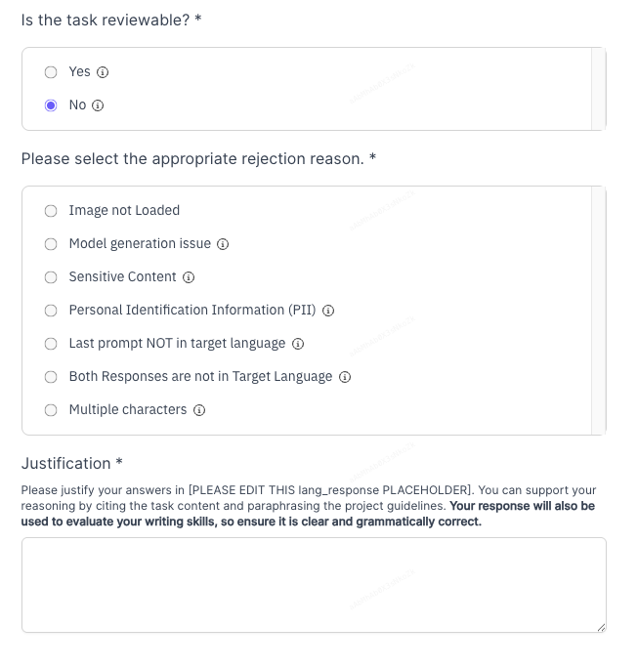
2. Click save and continue, then check the box to acknowledge you will reject the task in SRT and submit the task:
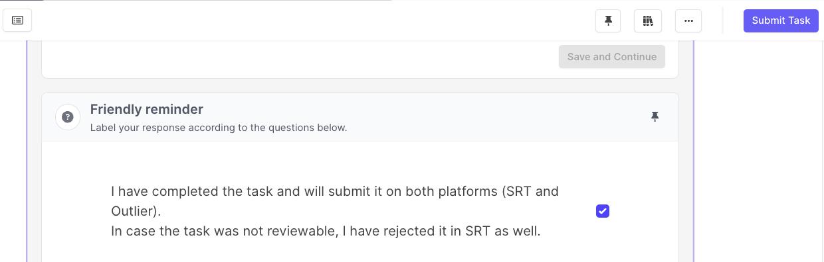

SRT:
- Click on Reject at the bottom left corner (scroll down):
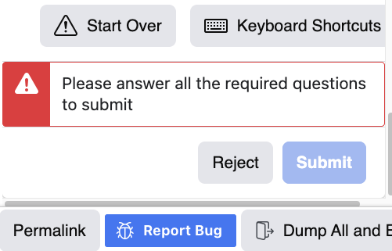

2. Select the reason that best describes the issue:

⚠️Clarification on ‘Halo Job is Done’: If your SRT task contains a Pop-up stating that the Halo Job is Done, please DO NOT skip it nor reject it. These tasks should be completed as usual and the Pop-up should be ignored.
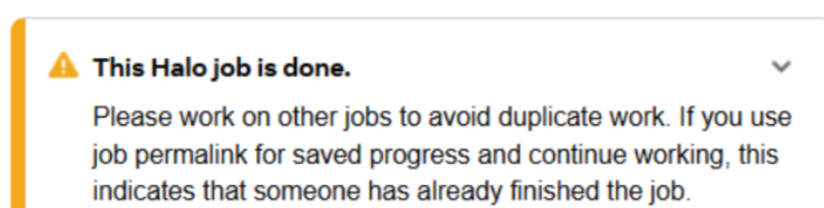

⚠️Do not click on any external links provided by the model in its responses or by users as part of the prompt or conversation. These links are not controlled or filtered by us and may potentially be unsafe. Verifying the safety or functionality of external links is outside the scope of this project.
🧑‍💻 Step 2: Evaluate the Prompt
After you read the character description and the entire conversation history, rate the last user’s prompt (last message from the user).
1.Select a tag for Prompt Scope: In-domain / Out-of-domain
- In-Domain: The last user message relates to a topic the agent is expected to handle, based on its described area of expertise.
- Out-of-Domain: The last user message is about a topic the agent is not expected to handle, based on its described area of expertise.

2.Select a tag for Prompt Quality:
- Good Quality: The user's prompt is easy to understand and has a clear intent.
- Bad Quality: Even with the provided context, the prompt is difficult to understand due to poor language quality.
- b) The intent is unclear, and the sentence remains nonsensical despite the context.
- c) A human reader would not be able to determine how to respond to the prompt.
2.Select a tag for Prompt Popularity
- Popular Prompt: This type of prompt commonly appears in conversations, whether between humans or between a human and an AI.
- Outlier Prompt (“Outlier” as in a data point that differs significantly from other observations! Meaning it is NOT popular.): This type of prompt is rare in both human-to-human and human-to-AI conversations.
(Note: Some prompts—like romantic ones, might not be typical in everyday human conversations, but are still common when users interact privately with AI. These should not be automatically considered outliers.)
Examples:
1. Prompt Scope: In-Domain/ Out-of-domain.
Character Description:
An AI assistant trained to give travel advice (flights, hotels, destinations).
Last User Message:
"Can you suggest some affordable hotels in Paris near the Eiffel Tower?"
✅ Tag: In-Domain
Reason: Travel advice is part of the agent’s area of expertise.

Out-of-Domain Example
Character Description:
An AI assistant trained to give travel advice (flights, hotels, destinations).
Last User Message:
"How do I fix a leaky faucet in my kitchen?"
✅ Tag: Out-of-Domain
Reason: Plumbing advice is unrelated to travel expertise.

2. Prompt Quality: Good vs. Bad
Good Quality Example
Last User Message:
"What's the best time of year to visit México City if I wanna see Jacaranda blossoms?"
✅ Tag: Good Quality
Reason: Clear intent, grammatically correct, easy to understand.

Bad Quality Example (Poor Language Quality)
Last User Message:
"Time mexicn go blosson when good best?"
✅ Tag: Bad Quality
Reason: The grammar is poor enough that the meaning is hard to reconstruct, even with context.

Bad Quality Example (Unclear Intent)
Last User Message:
"Is it flying when cold outside?"
✅ Tag: Bad Quality
Reason: It's unclear what the user is asking: about planes flying? Birds? Something else? Even with conversation history, it's ambiguous.

Bad Quality Example (No Response Possible)
Last User Message:
"Jungle ball after sometime maybe green sky?"
✅ Tag: Bad Quality
Reason: The sentence is nonsensical; a human wouldn't know how to respond meaningfully.

3. Prompt Popularity: Popular vs. Outlier
Popular Prompt Example
Last User Message:
"Can you recommend a good restaurant nearby?"
✅ Tag: Popular Prompt
Reason: Common in both human-human and human-AI conversations.

Outlier Prompt Example
Last User Message:
"Write a poem about my neighbor’s pet pig running for city council."
✅ Tag: Outlier Prompt
Reason: Creative and quirky; much rarer in typical conversations, even with AI.

Step 3: Response Diversity
Rate how different the last two responses are from each other. This helps us assess the variation in style, tone, and conversational approach between the models.
Diversity is [Low]
- The responses are nearly identical in language, tone, and conversational strategy.
- Both are likely to prompt the same follow-up from the user.
- Example: Both responses offer the same suggestion with minor wording changes or template language.
Diversity is [Mid]
- The responses are somewhat different in language or approach, but still share key similarities.
- They may lead to different follow-up prompts, but overlap is still likely.
- Example: One response is slightly more playful or detailed, but they both give similar advice.
Diversity is [High]
- The responses differ significantly in how they engage the user—whether through style, humor, tone, or direction.
- The user would almost certainly react very differently to each.
- Example: One response is emotionally supportive while the other uses humor or changes the topic entirely.
💡 Tip: Think about how the user might continue the conversation. If the responses are guiding them down very different paths, that’s High diversity.
1. Diversity: Low
Prompt:
"I'm feeling stressed about my upcoming exam. Any advice?"
Response A:
"It's important to stay calm. Try to take deep breaths and review your notes carefully."
Response B:
"Take a few deep breaths, stay calm, and go over your notes. You’ll do great!"
✅ Tag: Low Diversity
Reasons:
- Same advice (deep breaths + review notes).
- Same supportive tone.
- Only minor wording changes (surface-level rephrasing).
- Would likely lead to the same follow-up (e.g., "Any study tips?").

2. Diversity: Mid
Prompt:
"I'm feeling stressed about my upcoming exam. Any advice?"
Response A:
"Stay calm, pace your study sessions, and don't forget to get enough sleep before the exam."
Response B:
"Exams can be tough! Maybe create a colorful mind map to organize your notes—it can make studying more fun."
✅ Tag: Mid Diversity
Reasons:
- Different techniques suggested (pacing/sleep vs. creative mind maps).
- Tone shifts slightly (A = formal/practical, B = creative/cheerful).
- However, both are still on-topic and geared toward practical exam advice.
- Likely still leads to related follow-up (study tips, prep methods).

3. Diversity: High
Prompt:
"I'm feeling stressed about my upcoming exam. Any advice?"
Response A:
"Make a study schedule for the next few days, breaking the material into smaller chunks. Focus on the topics you find hardest first. Studying consistently now will help reduce your stress on exam day."
(Action-driven, productivity-focused advice.)
Response B:
"Right now, it’s more important to take care of your mental health. Step away from your study materials for a bit. Do something calming, like going for a walk or listening to music, and remind yourself that your worth isn’t defined by a single exam."
(Emotional-regulation, self-compassion advice.)
✅ Tag: High Diversity
Reasons:
- Completely different priorities:
- A = Pushes structured studying as the solution.
- B = Prioritizes emotional care over academic preparation.
- Very different tone and style:
- A = Directive, practical, a little urgent.
- B = Gentle, validating, and removes pressure.
- Different expected follow-up:
- After A: User might ask for more study techniques.
- After B: User might open up about anxiety or ask for emotional support activities.

❗Step 4. Tag Quality Issues for each Response
For each model response (A and B), identify and tag the specific types of issues using the categories below. This helps pinpoint what went wrong and supports consistent quality scoring.
In SRT, for each attribute, select all the tags that apply or leave the checkboxes blank if none apply.
In Outlier, you have the option to select checkboxes that say (none).
1. 🔠 Language Quality (issues):
How understandable and fluent the responses are.

- [Translationese]
- The response looks translated from other languages (usually English), and contains unnatural dialogue.
- [Undesired mixing languages]
- The response mixes multiple languages in an undesired way, hurting the overall understandability.
🗣️ 2. Conversation Quality (issues)
How the response engages with the user or flows within the dialogue.

- [Fail to understand context]
- The Model fails to understand the context (user’s intent, humor, flirting, role play, etc)
- [Overly formal tone]
- The response is overly formal, not natural dialogues.
- [Not Engaging]
- The response is preachy, stereotype, not concise, templated responses, etc.
- [Inconsistent Voice]
- The response is inconsistent voice/style/formatting with the character predefined style.
- [Low Quality Advice]
- The advice is cliche, not helpful or wrong in actuality.
- [False Refusal]
- The model fails to answer the question or provide helpful information for a valid request
🌍 3. Cultural Quality & Other (issues)

- [Cultural awareness]
- The response breaks the local cultural norms and values.
- [Other]
- Lack of empathy (emotionally flat, cold, patronizing, or dismissive tone.)
- Lack of humor (when applicable - dry or awkward when lightness/humor is appropriate or expected by the user.)
- Fails to be romantic (when applicable and expected by the user)
- Append the English translations (at the end of the response)
- Minor response generation issues:
- Responses that contain<|reserved_special_token_5|>
- Cropped (clearly incomplete) responses
- Infinite text loop
- PII in only one response (not a reason to reject the task)
- Tier 1 Sensitive content in only one response (not a reason to reject the task)

Note: If you select [Other], a free text box will appear to explain which issues you encountered.
🔍 Step 5: Additional Evaluations of Responses A and B (not in SRT)
Check off the box if the model response has any issues related to Grammar, Fluency, Presentation, and Understandability.
Only tagged in Outlier, not in SRT:
[Grammar, Fluency, Presentation, Understandability]
- The response contains noticeable or severe errors that make comprehension difficult, such as incorrect tenses, punctuation, or capitalization errors, and missing words.
- The response is poorly formatted and significantly impacts readability.
- The response contains severe issues in vocabulary, phrasing, and structure, making it unnatural and difficult to understand.
- The response is difficult to understand, with unclear phrasing or missing key information.
Step 6: Rank the last two responses
📏 How to Rank Responses Based on Bad Features (Step-by-Step)
- Count the number of Bad Features in each response.
2. If only one response has Bad Features:
- The one without Bad Features is much better than the one with Bad Features.
3. If both responses have Bad Features:
- Immediately select "Both are bad."
- Do not compare the number of Bad Features.
- Do not select "better" or "somewhat better."
4. If neither response has Bad Features:
- Compare based on overall impression and slight subjective preference.
- Use the following logic:
- Clear, strong preference for one → A is better than B (or vice versa).
- Slight preference, small stylistic difference → A is somewhat better than B (or vice versa).
- There is no "much better" label allowed if both responses are clean.

🚨 Important:
- Presence of any Bad Features = Automatic downgrade.
- No "better" or "somewhat better" allowed if Bad Features are present.
- If no Bad Features, use "better" vs "somewhat better" based on strength of your preference.

